**Web driver installation and integration in eclipse**

To install and integrate Selenium WebDriver in Eclipse, you need to:

1.Install Java SDK. You can download the latest version of Java SDK from the Oracle website.

2.Install Eclipse IDE. You can download the latest version of Eclipse IDE from the Eclipse website**.**

3. Download Selenium WebDriver. You can download the latest version of Selenium WebDriver from the Selenium website.

4.Configure Eclipse IDE with Selenium WebDriver.

To configure Eclipse IDE with Selenium WebDriver:

* Launch Eclipse.
* Create a new Java project.
* Right-click on the project and select Properties.
* In the Properties window, click on Java Build Path.
* Click on the Libraries tab.
* Click on the Add External JARs button.
* Navigate to the directory where you downloaded the Selenium WebDriver JAR files and select all of the JAR files.
* Click on Open.
* Click on OK to close the Properties window.
* Your Eclipse IDE is now configured with Selenium WebDriver. You can start writing Selenium test scripts in Eclipse.

To install Selenium WebDriver using Maven:

* Create a new Maven project in Eclipse.
* Open the project's pom.xml file.
* Add the following dependency to the pom.xml file:

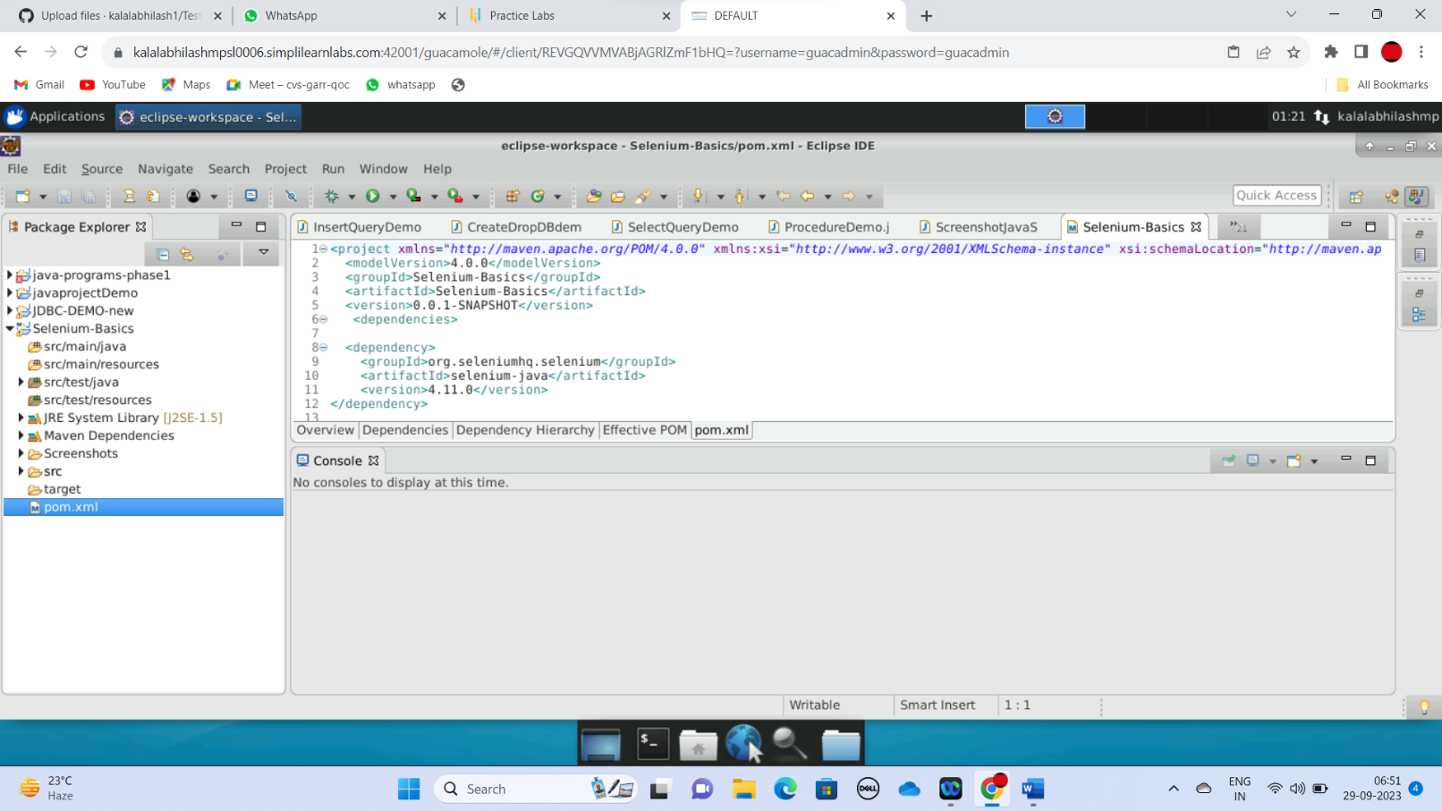

* Save the pom.xml file.
* Right-click on the project and select Maven > Update Project.

Maven will download the Selenium WebDriver dependency and all of its dependencies.

Once Selenium WebDriver is installed and integrated in Eclipse, you can start writing Selenium test scripts in Eclipse.

Here is a simple example of a Selenium test script in Eclipse:

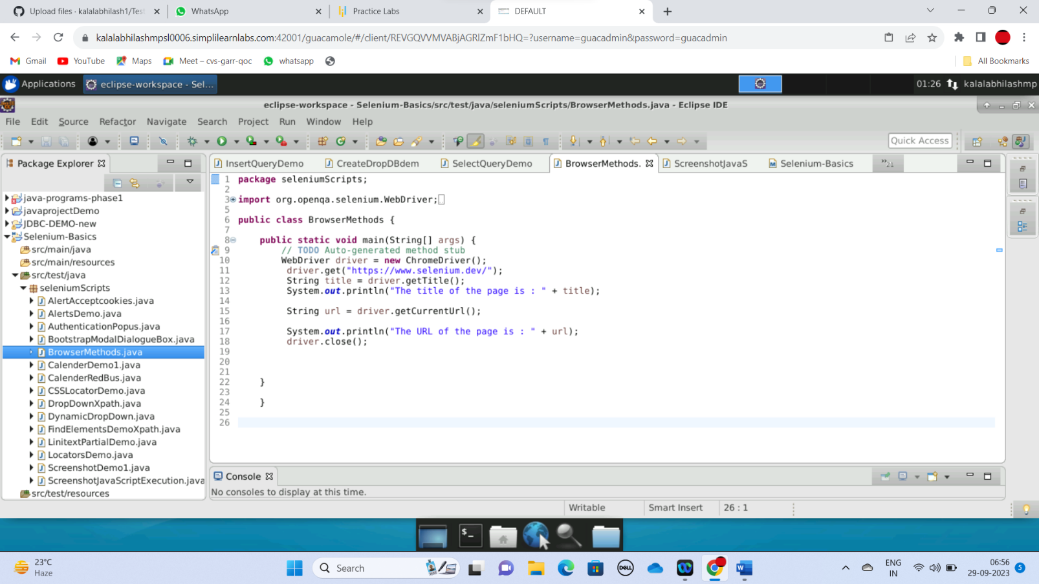

To run this test script, right-click on the test script class and select Run As > Java Application.

Selenium WebDriver will open a Chrome browser and navigate to the Google homepage. It will then enter the search term "Selenium" and click the search button. Finally, it will close the browser.

You can use Selenium WebDriver to write test scripts for any web browser. You can also use Selenium WebDriver to test web applications on different operating systems.